Girls Trip to Michigan (Cohesive Itinerary)

Trip overview
- Dates: Converge in Chicago on Aug 28–29; road trip begins Aug 29
- Primary loop: Chicago → Grand Rapids → Ludington → Sleeping Bear Dunes → Traverse City → Torch Lake → Charlevoix → Mackinac City / Mackinac Island → Frankenmuth → (Midland/Saginaw/Howell) → (Sarnia/Windsor, Canada) → Detroit → Ann Arbor → Kalamazoo → Home

Day-by-day plan

Aug 28–29 — Arrivals + Chicago
- Converge in Chicago (Aug 28/29)
- Rental car pickup (PU): Aug 29 — load up and leave by 2:00 PM (earlier preferred)
- Rental fee estimate: $570 (Costco/Budget); timing may change depending on arrivals

Aug 29 — Chicago → Grand Rapids → Ludington
- Grand Rapids (approx. 3 hr 18)
- Ludington (approx. 1 hr 45)
Note: Ludington is the port for the Badger Ferry (car ferry across Lake Michigan to Wisconsin).
- Climb lighthouse
- Pine Village
- Port Museum
- Kayak on the lake
- Overnight: Ludington possible (depends on departure time from Chicago)

Aug 30 — Ludington → Sleeping Bear Dunes → Traverse City
Sleeping Bear Dunes (approx. 2 hr)
- Pass required: $25 per car
- Site pass: https://www.recreation.gov/sitepass/74294
For a visit under ~3 hours:
- Drive the 7-mile Pierce Stocking Scenic Drive
- Do the Dune Climb (or watch!)
- Explore Glen Haven and the Maritime Museum
- Dip toes in Loon Lake
Traverse City (approx. 38 min)
- Wineries / distilleries
- City trail
- Tour town
- Lighthouse
- Eat well
- Overnight: Traverse City suggested

Aug 31 — Traverse City → Torch Lake → Charlevoix → Mackinac City
Torch Lake (approx. 40 min)
- Drive around the lake; consider touring Alden
- Clear-bottom kayaks or a boat ride down the lake
- Petoskey stone search (see locations below)
Petoskey stone search locations:
- Bryant Park Beach — 1097 Peninsula Dr, Traverse City, MI 49686
- Van’s Beach — 205 Cedar St, Leland, MI 49654
- Peterson Park — 10001 E Peterson Park Rd, Northport, MI 49670
- Magnus Park — 901 West Lake St, Petoskey, MI 49770
- Cross Village Beach — 100 Park Ln, Harbor Springs, MI 49740
Charlevoix (approx. 23 min)
- Lock
- Castle Farms
- Shop the town
- Lighthouse
Mackinac City (approx. 1 hr 10)
- Base for Mackinac Island
- Overnight: Mackinac City (2 nights suggested)

Sep 1–2 — Mackinac Island (day trips)
Mackinac Island day plan
- Target: 7:00 AM
- Park at the ferry dock OR call a shuttle if staying within ~1.5 miles of the ferry dock
- If driving to ferry: arrive 30 minutes prior to departure (7:30 AM)
- Costs: parking $10; ferry $52 per person round trip
- Ferry info: 1-800-638-9892
- On-island: ride bikes, tour town, eat well
- Return: around 4:00–4:30 PM

Sep 3 — Mackinac City → Frankenmuth → (Midland/Saginaw/Howell) → (Sarnia, Canada)
Frankenmuth (approx. 2 hr 50)
- Little Bavaria
- Cute / quaint
- Good food?
Midland / Saginaw / Howell (approx. 1 hr – 1 hr 30)
- Small livable towns
- Howell noted as ‘best overall downtown’!
Optional: Sarnia, Canada (approx. 2 hr to border)
- Overnight: Sarnia optional

Sep 4 — (Sarnia) → Windsor, Canada → Detroit
- Optional: Windsor, Canada (approx. 2 hr to border)
- Detroit: meet Julia downtown?
- Overnight: Julia’s

Sep 5 — Detroit → Ann Arbor → Kalamazoo → Home
- Ann Arbor (stop / explore)
- Kalamazoo (approx. 1 hr 46): good driving break
- Home (approx. 3 hr)

Notables / logistics

Canada driving (rental car)
- Vehicles may be driven into Canada with no restrictions.
- Notify the rental counter at pickup that you plan to drive into Canada so they can provide a Canadian Non-Resident Insurance Card.
- Download: www.avis.ca/content/dam/avis/na/ca/common/pdf-files/abg__canada_non_resident_card.pdf
- One additional driver fee may be waived for Costco members at participating locations.

Booking
- Budget Confirmation Number: 38128110US6
- Booked pickup: Aug 28
- Return: Sep 7

Rough cost estimate (per person, divided by 3)
- Hotels/Airbnbs: $200–250/night, 8 nights → ~$540 each
- Meals: $65/day → ~$520 each
- Gas: $240 total → ~$80 each
- Car rental: $570 total → ~$190 each
- Ferry/parking/entry fees: ~$100 total → ~$35 each
- Activities: kayaks/boat tours/misc (variable)
- Approx total: ~$1300 each (not including airfare)

Images from the original DOCX
These images were extracted from the original ‘Girls Trip to Michigan.docx’ and embedded here so they are explicitly accounted for.
Image 1
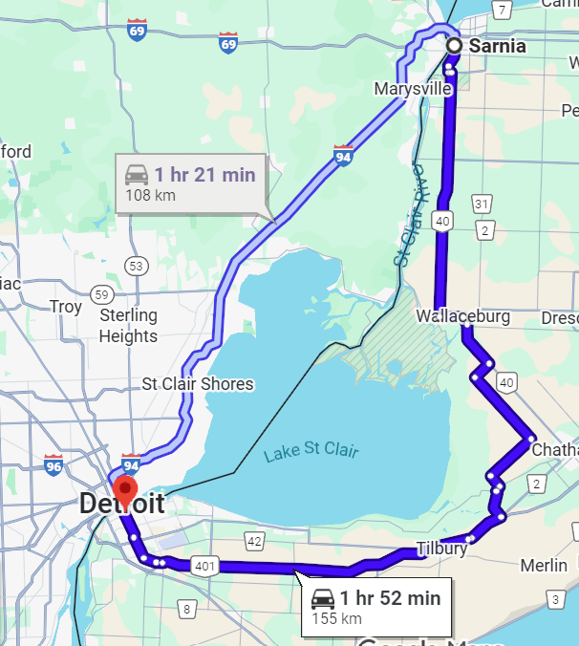
Image 2
